Jak zabranit spusteni vice nez jedne instance programu

**Kodovadlo – bootstrapper (nova verze 9.1.2019)**

**1)** private static string m_appGuid;

private static Mutex m_mutex;

**2)**  var propertiesConfiguration = m_globalContainer.Resolve<IConfigurationProvider>().GetConfig<PropertiesConfiguration>();

m_appGuid = propertiesConfiguration.AppGuid;

m_mutex = new Mutex(true, m_appGuid);

**3)** private bool CheckMultipleProgramInstances()

{

string applicationName = Assembly.GetExecutingAssembly().FullName;

applicationName = applicationName.Substring(0, applicationName.IndexOf(','));

if (!m_mutex.WaitOne(TimeSpan.Zero, true))

{

MessageBox.Show(string.Format(Localisation.ApplicationIsAlreadyRunning, applicationName),

Localisation.ApplicationIsAlreadyRunningDialogTitle, MessageBoxButton.OK, MessageBoxImage.Warning);

if (Log.IsWarnEnabled)

Log.Warn($"More than 1 program instances!");

return false;

}

return true;

}

**4)** private void DisplaySplashScreen()

{

var splashScreen = m_globalContainer.Resolve<ISplashScreen>();

var initializationFailed = false;

splashScreen.DoBeforeClose = () =>

{

RegisterComponents();

**if (!CheckMultipleProgramInstances())**

**{**

**initializationFailed = true;**

**return;**

**}**

**5) Ve tride PropertiesConfiguration:**

[ConfigurationProperty(nameof(AppGuid), IsRequired = true)]

public string AppGuid => (string)this[nameof(AppGuid)];

**6) A v kazdem app.configu (podle prostredi):**

AppGuid="MIR.Media.Coding.CZ-Test"

**Kodovadlo – bootstrapper: (Predchozi verze)**

private bool CheckMultipleProgramInstances()

{

string applicationName = Assembly.GetExecutingAssembly().FullName;

applicationName = applicationName.Substring(0, applicationName.IndexOf(','));

// Povolit spustene prave 2 instance K2

string procName = Process.GetCurrentProcess().ProcessName;

if (Process.GetProcessesByName(procName).Length > MaximumProgramInstances)

{

MessageBox.Show(string.Format(Localisation.ApplicationIsAlreadyRunning, applicationName),

Localisation.ApplicationIsAlreadyRunningDialogTitle, MessageBoxButton.OK, MessageBoxImage.Warning);

if (m_log.IsWarnEnabled)

m_log.Warn($"More than {MaximumProgramInstances} program instances!");

return false;

}

return true;

}

**Simlog – mutex**

Mam guid definovany v configu. Mutex ho bere jako parametr v konstruktoru. Na zaklade toho, ze si muzu dat do configu kazdeho prostredi unikatni appGuid mi mutex ohlida jen tento proces a proto bude mozne pustit ClickOnce pro kazde prostredi, ale vzdy jen jednu instanci od kazdeho environmentu.

**common.config:**





**ApplicationProperties**

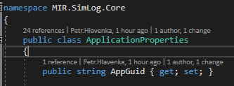

**AppBootstrapper:**



**Inicializace je az v metode Configure, potom co je resolvnuty Castle.Current a nainstalovano z configu:**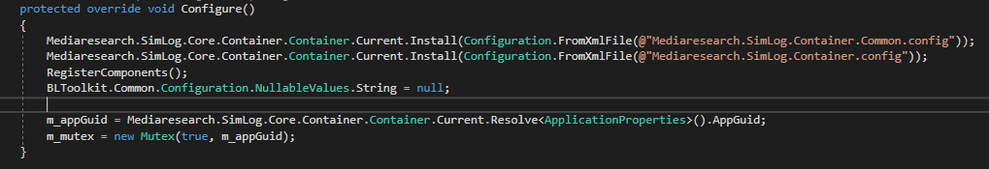

**A samotny mutex:**

